1. Output 1: Identify all fraud credit cards from input transactions.csv

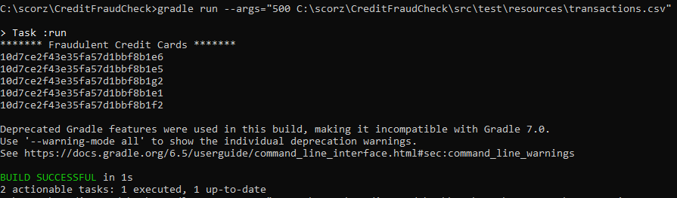

1. Output 2: File not found



1. Output 3: Input File validation – Incorrect date format



1. Output 4: Input file validation – Incorrect amount format



1. Output 5: Invalid threshold format in arguments

